**CSE370 – Lab 3**

**Name: Abrar Mojahid Rafi**

**Id: 22101593**

**Lab Section 05**

**Question 01:**

SELECT customer.customer_name, loan.loan_number

-> FROM borrower

-> JOIN loan ON borrower.loan_number = loan.loan_number AND loan.branch_name = 'Downtown'

-> JOIN customer ON borrower.customer_id = customer.customer_id;

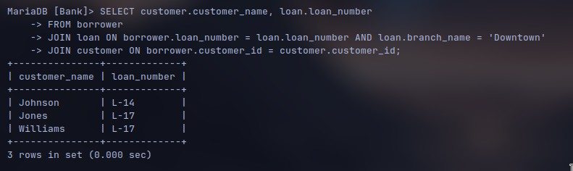

**Question 02:**

SELECT c1.customer_name AS Customer1, c2.customer_name AS Customer2, c1.customer_city AS City

-> FROM customer c1

-> JOIN customer c2 ON c1.customer_city = c2.customer_city AND c1.customer_id < c2.customer_id;

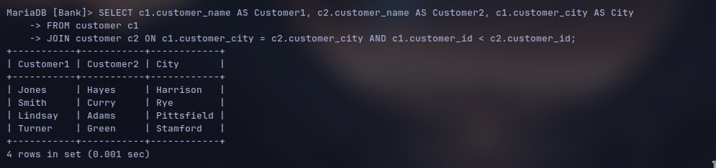

**Question 03:**

SELECT account.branch_name AS Branch_name, SUM(account.balance * 0.04) AS Total_Interest

-> FROM account

-> GROUP BY account.branch_name;

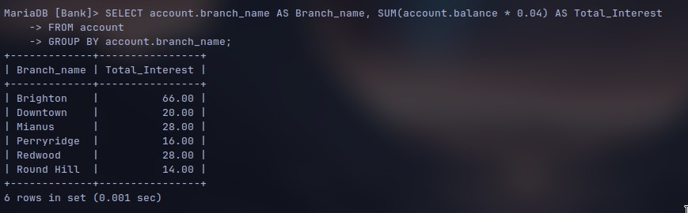

**Question 04:**

SELECT b.branch_city, a.account_number, a.balance

-> FROM account a

-> INNER JOIN branch b ON a.branch_name = b.branch_name

-> WHERE a.balance = (

-> SELECT MAX(a2.balance) FROM account a2

-> INNER JOIN branch b2 ON a2.branch_name = b2.branch_name

-> WHERE b2.branch_city = b.branch_city

-> )

-> ORDER BY b.branch_city;

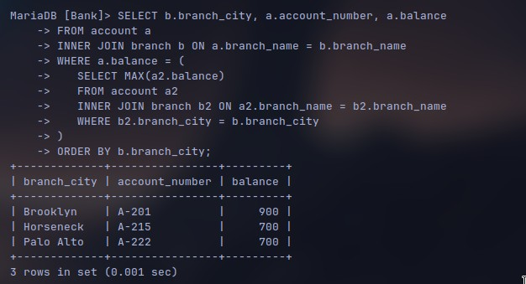

**Question 05:**

SELECT * FROM (

-> SELECT loan.loan_number, amount, customer_name

-> FROM loan INNER

-> JOIN borrower ON loan.loan_number = borrower.loan_number INNER

-> JOIN customer ON customer.customer_id = borrower.customer_id order

-> BY amount DESC limit 5

-> )

-> AS table1

-> ORDER BY amount, loan_number DESC;

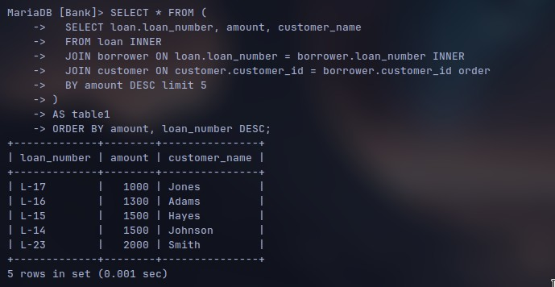

**Question 06:**

SELECT DISTINCT c.customer_name

-> FROM customer c

-> INNER JOIN depositor d ON c.customer_id = d.customer_id

-> INNER JOIN account a ON d.account_number = a.account_number

-> INNER JOIN borrower b ON c.customer_id = b.customer_id

-> INNER JOIN loan l ON b.loan_number = l.loan_number AND l.branch_name = a.branch_name

-> WHERE a.branch_name = 'Perryridge';

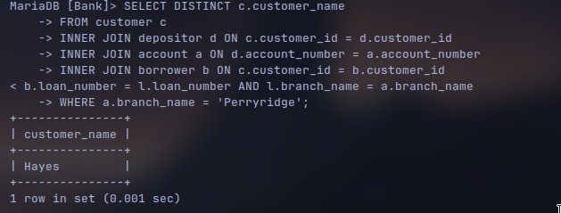

**Question 07:**

SELECT c.customer_name, COUNT(*) AS number_of_loans, SUM(l.amount) AS total_loan

-> FROM customer c

-> JOIN borrower b ON c.customer_id = b.customer_id

-> JOIN loan l ON b.loan_number = l.loan_number

-> WHERE c.customer_id IN (

-> SELECT b2.customer_id

-> FROM borrower b2

-> GROUP BY b2.customer_id

-> HAVING COUNT(*) >= 2

-> )

-> GROUP BY c.customer_id

-> ORDER BY total_loan DESC;

